BRAINSTORMING AND IDEATION PHASE

Project Title: Auto Ticket Classification using Flow Designer

1. Problem Identification

In ServiceNow, support tickets are created for different types of issues such as hardware problems, software problems, network issues, and access-related problems. In the manual process, support agents need to read the ticket details, identify the appropriate category, update the ticket, and assign it to the correct support group.

When many tickets are received, manual classification takes more time and may result in inconsistent classification. Therefore, an automated solution is required to classify tickets and route them to the appropriate assignment group.

2. Brainstorming Idea

The main idea of the project is to use ServiceNow Flow Designer to automatically classify newly created support tickets.

The Flow Designer workflow reads the ticket information such as Short Description and Description. It checks the ticket information against predefined conditions or keywords. Based on the matching condition, the system identifies the appropriate category and routes the ticket to the relevant assignment group.

3. Proposed Idea

The proposed system will automatically process support tickets using ServiceNow Flow Designer. The workflow will perform the following steps:

1. A new support ticket is created in ServiceNow.

2. Flow Designer automatically triggers the workflow.

3. The flow reads the ticket information.

4. The ticket details are checked against predefined conditions or keywords.

5. The appropriate category is identified.

6. The ticket record is updated with the selected category.

7. The ticket is routed to the appropriate assignment group.

8. If no matching condition is found, the ticket follows a default or manual-review path.

9. Classification Categories

The following ticket categories are identified for the project:

Ticket Type: Hardware Issue
Example Keywords: Laptop, Keyboard, Mouse, Printer
Category: Hardware

Ticket Type: Software Issue
Example Keywords: Application, Software, Installation
Category: Software

Ticket Type: Network Issue
Example Keywords: Wi-Fi, Internet, Network, Connection
Category: Network

Ticket Type: Access Issue
Example Keywords: Login, Password, Account, Access
Category: Access

Ticket Type: No Matching Condition
Example Keywords: No predefined keyword
Category: Default / Review

5. Key Features

The main features identified during the brainstorming process are:

• Automatic ticket classification
• Automatic Flow Designer triggering
• Keyword or condition-based classification
• Automatic category update
• Automatic assignment group routing
• Default or manual review for unmatched tickets
• Reduced manual work
• Consistent ticket handling
• Easy modification of classification rules
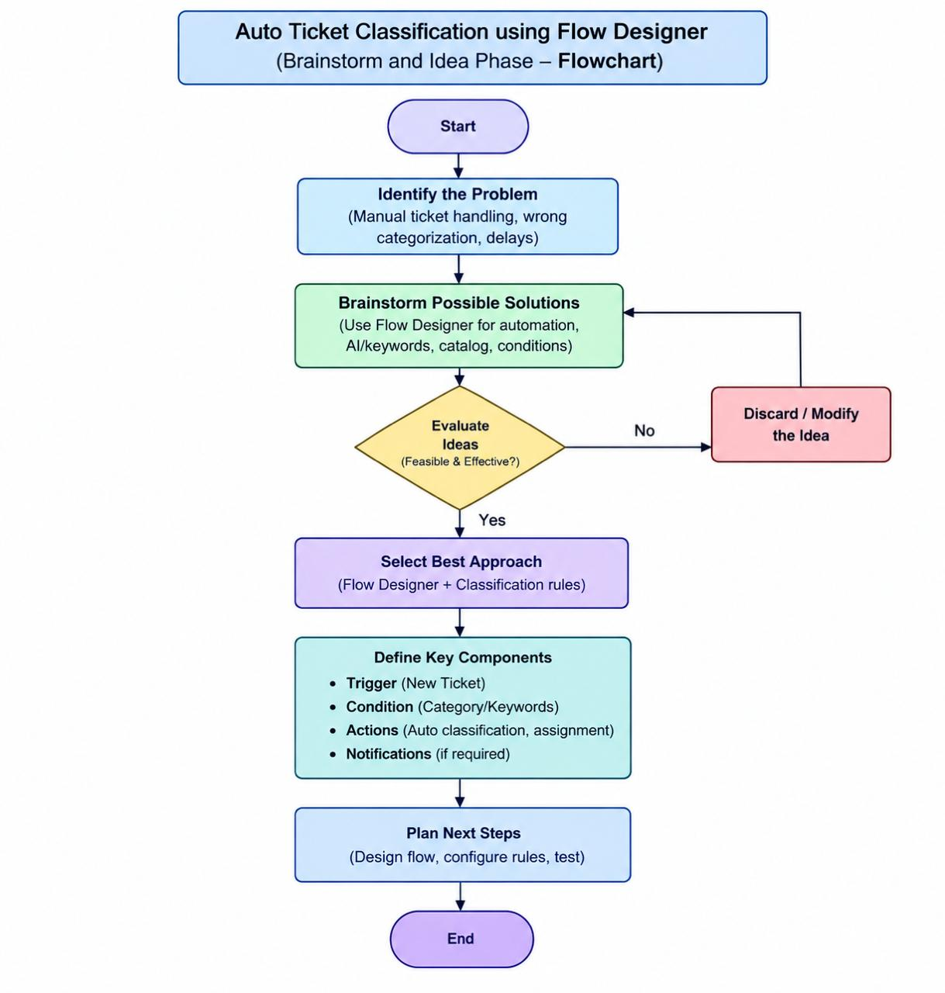

6. Workflow Idea

The overall workflow of the proposed system is:

New Ticket Created
↓
Flow Designer Trigger
↓
Read Ticket Details
↓
Check Conditions / Keywords
↓
Identify Ticket Category
↓
Update Ticket Record
↓
Assign Assignment Group
↓
End

7. Expected Benefits

The proposed system is expected to provide the following benefits:

• Reduces repetitive manual classification work.
• Saves time in ticket processing.
• Provides consistent classification of tickets.
• Automatically routes tickets to the appropriate support team.
• Reduces unnecessary manual steps.
• Makes classification rules easier to maintain and modify.
• Provides a structured process for handling support tickets.

8. Tools and Technologies

The following tools and technologies are considered for implementing the project:

• ServiceNow Platform
• Flow Designer
• Incident / Ticket Management
• ServiceNow Tables and Records
• Web Browser

9. Final Idea

The final idea selected for the project is to develop an Auto Ticket Classification system using ServiceNow Flow Designer. The system will automatically process newly created tickets, classify them using predefined conditions or keywords, update the ticket category, and route the ticket to the appropriate assignment group.

Tickets that do not match any predefined rule will follow a default or manual-review path. This provides a structured foundation for implementing and testing the Auto Ticket Classification system.

